INSA TALENT
SUMMER CAMP 5TH BATCH (2026)

TECHNICAL PROJECT DOCUMENTATION

MediGuard (A SMART NURSE STATION)
Department: Embedded System
Mentor: Gutember
Group Members
- Abigiya Mengistu CTC-1822-26
- Hewan kifle CTC-917-26
- Nebiyat Biadglign CTC-1984-26
- Tsion Belete CTC-7655-26
- Yanet Dagne CTC-3160-26
- Yedi Benyam CTC-2525-26
- Zenebwork Wubale CTC-3567-26
Submission Date: Oct 26, 2026

Acknowledgment
We would like to express our sincere gratitude to the INSA Talent Summer Camp , for providing us with the opportunity, learning environment, and resources to develop our technical knowledge and practical skills through this project.
We extend our heartfelt appreciation to our mentor, Gutember, Salem and Amanuel for the guidance, support, and valuable feedback provided throughout the development of MediGuard, our Smart Nurse Station project. Their guidance has helped us strengthen our understanding of embedded systems, hardware design, programming, and system integration.
We are also grateful to all the INSA summer Camp staff members for providing an environment that encourages innovation, teamwork, and practical problem solving. We would like to thank everyone who contributed directly or indirectly to the development of this project.
Finally, we acknowledge the dedication, cooperation, and collective effort of all our group members. Their contributions, ideas, and commitment have been essential to the progress of MediGuard. This project has provided us with a valuable opportunity to apply our theoretical knowledge to a practical engineering challenge and to develop skills that will support our future academic and professional growth.

Abstract
MediGuard is a Smart Nurse Station project designed to support routine nursing activities through the integration of embedded systems, monitoring technologies, and a centralized dashboard. The project aims to address selected healthcare support challenges by bringing multiple monitoring and reminder functions together within a modular system. The initial implementation focuses on three main modules: intravenous (IV) fluid monitoring, room temperature regulation, and medicine reminders.
The IV fluid monitoring module is designed to monitor fluid levels using a load cell and HX711 load cell amplifier, while an infrared sensor is used to detect fluid flow activity. The room temperature regulation module monitors the surrounding temperature and supports temperature control through an appropriate actuator and driver circuit. The medicine reminder module uses scheduled timing to generate reminders for medication related activities. A centralized dashboard provides an interface for presenting system information and module statuses, supporting easier observation of the system from a single point.
MediGuard is developed as a prototype to demonstrate how embedded technologies can be applied to healthcare support tasks. Its performance and limitations must be evaluated through appropriate testing, and the prototype is not intended to replace qualified healthcare professionals or certified medical equipment.

Contents
TECHNICAL PROJECT DOCUMENTATION 1
Acknowledgment 2
Abstract 3
CHAPTER ONE: INTRODUCTION 4
1.1 Background of the Project 4
1.2 Problem Statement 4
1.3 Project Objectives 4
1.3.1 General Objective 4
1.3.2 Specific Objectives 4
1.4 Scope of the Project 5
1.5 Limitations of the Project 5
1.6 Significance of the Project 5
CHAPTER TWO: LITERATURE REVIEW 6
2.1 Introduction 6
2.2 Smart Nurse Stations 6
2.3 IV Fluid Monitoring Systems 6
2.4 Room Temperature Regulation Systems 7
2.5 Medicine Reminder Systems 7
2.6 Centralized Dashboard Systems 7
2.7 Research Gap and Project Contribution 7
CHAPTER THREE: SYSTEM REQUIREMENTS AND DESIGN 8
3.1 Introduction 8
3.2 System Requirements 8
3.2.1 Functional Requirements 8
3.2.2 Non-Functional Requirements 9
3.3 Overall System Architecture 9
3.4 Hardware Requirements 10
3.4.1 Microcontroller 10
3.4.2 IV Fluid Monitoring Components 10
3.4.3 Temperature Regulation Components 11
3.4.4 Medicine Reminder Components 11
3.4.5 Dashboard and Communication Components 11
3.4.6 Power Supply 11
3.5 Software Requirements 11
3.5.1 Embedded Firmware 11
3.5.2 Dashboard Software 12
3.6 System Operation 12
CHAPTER FOUR: HARDWARE DESIGN AND IMPLEMENTATION 13
4.1 Introduction 13
4.2 Microcontroller Unit 13
4.3 IV Fluid Monitoring Module 13
4.3.1 Load Cell 14
4.3.2 HX711 Load-Cell Amplifier 14
4.3.3 Infrared Flow-Detection Sensor 15
4.3.4 IV Status Indication 15
4.4 Room Temperature Regulation Module 15
4.4.1 Temperature Sensor 16
4.4.2 Actuator and Driver Circuit 16
4.5 Medicine Reminder Module 16
4.5.1 Real-Time Clock Module 16
4.5.2 Notification Components 17
4.6 Dashboard and Communication Hardware 17
4.7 Power Supply Design 18
4.8 Hardware Integration 18
CHAPTER FIVE: SOFTWARE DESIGN AND IMPLEMENTATION 19
5.1 Introduction 19
5.2 Software Architecture 19
5.3 Embedded Firmware Development 19
5.4 IV Fluid Monitoring Software Flow 20
5.5 Temperature Regulation Software Flow 21
5.6 Medicine Reminder Software Flow 22
5.7 Dashboard Software Development 23
5.8 Software Testing and Debugging 23
CHAPTER SIX: TESTING, RESULTS, AND DISCUSSION 24
6.1 Introduction 24
6.2 Testing and Evaluation Methodology 24
6.3 IV Fluid Monitoring Module Results 24
6.3.1 Proteus Circuit Simulation 25
6.3.2 IV Monitoring PCB Design 26
6.3.3 IV Monitoring Test Results 26
6.4 Room Temperature Regulation Module Results 27
6.4.1 Proteus Circuit Simulation 27
6.4.2 Temperature Regulation PCB Design 28
6.4.3 Temperature Regulation Test Results 29
6.5 Medicine Reminder Module Results 29
6.5.1 Proteus Circuit Simulation 29
6.5.2 Medicine Reminder PCB Design 30
6.5.3 Medicine Reminder Test Results 31
6.6 PCB Design Overview 32
6.7 System Integration and Overall Results 32
6.9 Discussion 33
CHAPTER SEVEN: FUTURE IMPROVEMENTS 33
7.2 Integration of Heart Rate and Blood Oxygen Monitoring 33
7.3 Integration of ECG Monitoring 33
7.4 Integration of Blood Pressure Monitoring 34
7.5 Integration of Body Temperature Monitoring 34
7.6 Integration of a Wireless Nurse-Call System 34
7.7 Expansion of Wireless Communication and Dashboard 34
7.8 PCB, Power Management, and Hardware Expansion 35
7.9 System Validation and Safety 35
CHAPTER EIGHT: CONCLUSION 35

CHAPTER ONE: INTRODUCTION

1.1 Background of the Project
Healthcare facilities depend on nurses to monitor patients, manage routine care activities, and respond to changing conditions. However, tasks such as checking intravenous (IV) fluid levels, maintaining appropriate room temperatures, and keeping track of medication schedules can require continuous attention. When these activities are managed separately, monitoring and timely responses may become more difficult.
Advances in embedded systems and automation provide opportunities to support these routine tasks through electronic monitoring, alerts, and centralized information displays. MediGuard, a Smart Nurse Station, is designed to integrate selected healthcare-support functions into one modular system. Its initial implementation consists of three modules: IV fluid monitoring, room temperature regulation, and medicine reminders, supported by a centralized dashboard.

1.2 Problem Statement
Routine nursing activities involve monitoring multiple conditions and schedules, often requiring repeated manual checks. Without suitable monitoring and reminder mechanisms, changes in IV fluid status, room temperature, or medication schedules may be overlooked or require additional attention from healthcare staff.
MediGuard addresses this challenge by proposing an integrated embedded system that monitors selected conditions, provides reminders and alerts, and presents relevant information through a centralized dashboard. The project aims to demonstrate how these technologies can support routine nursing activities while keeping clinical decisions under the responsibility of qualified healthcare professionals.

1.3 Project Objectives

1.3.1 General Objective
To design and develop MediGuard, a modular Smart Nurse Station that integrates IV fluid monitoring, room temperature regulation, medicine reminders, and a centralized dashboard to support routine nursing activities.

1.3.2 Specific Objectives
- To develop an IV fluid monitoring module that detects fluid levels and flow conditions.
- To design a room temperature monitoring and regulation module.
- To implement a medicine reminder module based on scheduled timing.
- To develop a centralized dashboard for presenting information from the system modules.
- To integrate the modules into a unified system.
- To test the functionality of the implemented modules and evaluate their performance.
- To establish a modular design that can accommodate future improvements.

1.4 Scope of the Project
The project focuses on the design and development of a prototype Smart Nurse Station comprising three main modules: IV fluid monitoring, room temperature regulation, and medicine reminders. The system also includes a centralized dashboard intended to display relevant module statuses and alerts.
The work covers hardware design, embedded software development, dashboard development, system integration, and functional testing. Additional features, such as wireless nurse-call functionality and expanded patient vital-sign monitoring, are considered potential future improvements rather than core features of the initial implementation.

1.5 Limitations of the Project
MediGuard is a prototype developed within the available time, budget, and component constraints. Its sensing accuracy and reliability depend on the selected components, calibration, and testing conditions. The medicine reminder module provides scheduled reminders but does not independently verify that medication has been taken. Similarly, the IV monitoring module supports observation of fluid level and flow conditions but does not automatically regulate the clinical infusion rate..

1.6 Significance of the Project
MediGuard provides a practical demonstration of how embedded systems can be integrated to support selected healthcare activities. By combining monitoring, reminders, and a centralized dashboard, the project aims to make relevant system information easier to access and demonstrate the potential for reducing repetitive manual monitoring tasks.
The project also provides practical engineering experience in sensor interfacing, microcontroller programming, hardware design, dashboard development, and system integration. Its modular architecture creates a foundation for future expansion into a more comprehensive Smart Nurse Station.

CHAPTER TWO: LITERATURE REVIEW

2.1 Introduction
This chapter reviews existing technologies related to Smart Nurse Stations and the three core modules implemented in MediGuard. It examines current approaches to IV fluid monitoring, room temperature regulation, medicine reminder systems, and centralized dashboards. The purpose is to identify how these technologies are used in healthcare and how MediGuard combines them into a single modular platform.

2.2 Smart Nurse Stations
A Smart Nurse Station is an integrated healthcare support system that combines monitoring, communication, and information management to assist nursing staff. Unlike traditional nurse stations that primarily serve as communication points, smart nurse stations can collect information from different devices, display alerts, and provide a centralized view of patient-related activities.
Modern systems developed by companies such as Ascom, Rauland, TekTone, and Stryker (Vocera) demonstrate how centralized monitoring and clinical communication can improve workflow by bringing multiple functions into a single platform. While these commercial systems often include advanced communication networks and hospital-wide integration, they are generally expensive and designed for large healthcare facilities.
MediGuard follows a similar concept on a prototype scale by integrating multiple healthcare-support functions into one modular Smart Nurse Station.

2.3 IV Fluid Monitoring Systems
Intravenous (IV) therapy is one of the most common medical procedures in healthcare facilities. Nurses traditionally monitor IV fluid levels through visual inspection, which requires regular attention.
Several research projects have introduced electronic IV monitoring systems that use load cells to measure the weight of an IV bag and estimate the remaining fluid quantity. The HX711 load-cell amplifier is commonly used because it converts small analog signals into digital data that can be processed by a microcontroller.
Some systems also include infrared (IR) sensors to detect whether fluid is flowing through the IV tube. Combining weight measurement with flow detection can improve monitoring by identifying low-fluid conditions and possible flow interruptions.
The IV module in MediGuard adopts this approach by using a load cell with an HX711 amplifier and an IR sensor to monitor IV status and generate alerts.

2.4 Room Temperature Regulation Systems
Maintaining a suitable room temperature contributes to patient comfort and supports healthcare environments. Traditional temperature regulation relies on thermostats, while embedded systems allow automatic monitoring and control using digital sensors and microcontrollers.
A typical embedded temperature-control system continuously measures ambient temperature and compares it with a predefined temperature range. When the measured temperature exceeds or falls below the configured limits, the controller activates a suitable heating or cooling mechanism.
MediGuard incorporates this concept through a room temperature regulation module that measures ambient temperature and controls a suitable actuator according to programmed conditions.

2.5 Medicine Reminder Systems
Medication schedules are an important part of patient care. Missing or delaying scheduled medication can affect treatment, making reminder systems useful for supporting routine nursing activities.
Electronic medicine reminder systems commonly use Real-Time Clock (RTC) modules to maintain accurate time and generate notifications according to programmed schedules. These systems may use displays, LEDs, or alarms to notify users when medication is due.
The medicine reminder module in MediGuard uses scheduled timing to generate reminders, helping demonstrate how embedded systems can support medication management without replacing clinical decision-making.

2.6 Centralized Dashboard Systems
Modern healthcare increasingly uses dashboards to present information from multiple devices in one location. A centralized dashboard allows healthcare personnel to monitor different system conditions without checking each device individually.
Dashboards typically display sensor readings, alert notifications, and system status in an organized interface. When connected through communication technologies such as Wi-Fi or local networks, they can receive updates from multiple monitoring devices.
The MediGuard dashboard serves as the central interface of the Smart Nurse Station by displaying information from the IV monitoring, room temperature regulation, and medicine reminder modules in one location.

2.7 Research Gap and Project Contribution
Existing healthcare technologies often focus on individual functions such as IV monitoring, temperature control, or medication reminders. Commercial smart nurse stations integrate multiple systems but are generally designed for large healthcare facilities and may require significant investment.
MediGuard addresses this gap by developing a modular Smart Nurse Station prototype that combines three healthcare-support functions with a centralized dashboard in a single embedded-system platform. The project demonstrates how multiple modules can operate together while providing a foundation for future expansion, including wireless nurse-call functionality and additional patient-monitoring modules.
The main contribution of MediGuard is not the development of a single monitoring device, but the creation of an integrated Smart Nurse Station architecture capable of supporting multiple healthcare functions within one coordinated system.

CHAPTER THREE: SYSTEM REQUIREMENTS AND DESIGN

3.1 Introduction
This chapter presents the system requirements and overall design of MediGuard, a Smart Nurse Station developed to integrate multiple healthcare-support functions into one platform. It describes the functional and non-functional requirements, system architecture, hardware and software requirements, and the interaction between the main system components.
The system consists of three primary modules: IV fluid monitoring, room temperature regulation, and medicine reminders. A centralized dashboard provides an interface for presenting relevant information from these modules.

3.2 System Requirements
System requirements define the functions MediGuard must perform and the conditions under which it should operate.

3.2.1 Functional Requirements
The functional requirements describe the main operations of the system.
- IV fluid monitoring: Measure the weight of the IV fluid container using a load cell and HX711 amplifier.
- Flow detection: Use an infrared sensor to detect fluid-flow activity and identify possible interruptions.
- Alert generation: Provide notifications when configured conditions, such as low IV fluid levels or interrupted flow, are detected.
- Temperature monitoring: Measure the surrounding room temperature using a temperature sensor.
- Temperature regulation: Control a suitable heating or cooling actuator according to predefined temperature conditions.
- Medicine reminders: Generate reminders based on configured medication schedules.
- Centralized dashboard: Present relevant module statuses, sensor readings, and alerts through a unified interface.
- System integration: Coordinate the three modules and make their relevant information available to the dashboard.
- Future expandability: Support the addition of further healthcare-support modules without requiring a complete redesign of the system.

3.2.2 Non-Functional Requirements
The non-functional requirements describe the expected qualities of the system.
- Reliability: The system should operate consistently under its intended testing conditions.
- Accuracy: Sensors should provide sufficiently accurate readings after appropriate calibration.
- Usability: The dashboard should present information in a clear and understandable manner.
- Modularity: Each module should be designed so that it can be developed, tested, and maintained independently.
- Maintainability: The hardware and software should be organized to simplify troubleshooting and future modifications.
- Expandability: The architecture should allow additional modules to be incorporated in future versions.
- Safety: The prototype should operate within appropriate electrical and component limits and should not replace certified medical equipment.

3.3 Overall System Architecture
MediGuard follows a modular architecture in which each monitoring or control function operates as a separate module within the larger Smart Nurse Station. Each module collects information or performs an assigned task, while the centralized dashboard presents relevant information to the user.
The IV fluid monitoring module uses a load cell, HX711 amplifier, and infrared sensor to obtain information about fluid weight and flow activity. The room temperature regulation module measures ambient temperature and controls an appropriate actuator. The medicine reminder module uses scheduled timing to generate medication-related notifications.
The information generated by these modules is made available to the centralized dashboard through the selected communication and software interfaces. The dashboard serves as the main monitoring interface for the system.
The overall architecture can be represented as follows:
IV Fluid Monitoring Module
Load Cell + HX711 + IR Sensor
↓
Module Controller and Data Processing
Room Temperature Regulation Module
Temperature Sensor + Controller + Actuator
↓
Module Controller and Data Processing
Medicine Reminder Module
Real-Time Clock (RTC) + Reminder Logic
↓
Module Controller and Data Processing
All Modules → wifi module → MediGuard Dashboard → Status Display and Alerts.

3.4 Hardware Requirements
The hardware components are selected according to the sensing, processing, timing, control, and communication requirements of each module.

3.4.1 Microcontroller
The microcontroller processes sensor information, executes programmed control logic, and manages the functions of the connected components. The ATmega328P is used in the embedded-system development of MediGuard. Its digital input/output pins and peripheral interfaces support sensor interfacing and module control.

3.4.2 IV Fluid Monitoring Components
The IV monitoring module includes the following components:
- Load cell: Measures the weight of the IV fluid container.
- HX711 amplifier: Amplifies and converts the load-cell signal into digital measurements.
- Infrared sensor: Detects fluid-flow activity or interruptions according to the sensor's operating principle.
- Indicator components: led.

3.4.3 Temperature Regulation Components
The temperature regulation module consists of a temperature sensor, a processing unit, and an appropriate actuator with its driver circuit a fan and a heating compartment. The sensor provides ambient temperature measurements, while the controller compares the readings with predefined limits and determines when the actuator should operate.

3.4.4 Medicine Reminder Components
The medicine reminder module uses a Real-Time Clock (RTC) module to maintain time and support scheduled reminders. A suitable display or notification component (LCD) and a detecting actuator ( led) .

3.4.5 Dashboard and Communication Components
The communication hardware and protocol must be selected according to the dashboard platform, controller capabilities, and required update frequency.

3.4.6 Power Supply
The power supply provides the voltage and current required by the microcontrollers, sensors, communication components, and actuators. Appropriate voltage regulation and power distribution are necessary for stable operation. Components with different voltage requirements must be supplied according to their specifications.

3.5 Software Requirements
The software is responsible for processing sensor measurements, executing control logic, managing reminders, and presenting system information.

3.5.1 Embedded Firmware
The embedded firmware is responsible for:
- Initializing the microcontroller and connected peripherals.
- Reading and processing sensor data.
- Calculating IV fluid weight and evaluating flow status.
- Comparing temperature measurements with configured limits.
- Managing medicine reminder schedules.
- Generating alerts when predefined conditions are detected.
- Preparing module information for communication with the dashboard.
The firmware should be organized into separate functions or modules to improve readability, testing, and maintainability.

3.5.2 Dashboard Software
The dashboard provides a centralized user interface for monitoring MediGuard. Its main functions include displaying module status, presenting relevant readings, and indicating alerts.
The dashboard software should be designed to distinguish normal conditions from conditions requiring attention. If communication is interrupted, the interface should avoid presenting outdated information as if it were current.

3.6 System Operation
MediGuard operates through a sequence of sensing, processing, communication, and presentation.
First, each module collects information from its connected sensor or timing component. The module controller processes this information and evaluates it against the programmed conditions. When a condition requiring attention is detected, the module generates the appropriate status or alert.
The relevant information is then transferred through the system's communication interface to the centralized dashboard. The dashboard displays the available readings, module statuses, and alerts so that a user can review the system's condition.
For temperature regulation, the controller also operates the selected actuator according to the programmed control logic. For medicine reminders, the system compares the current time with the configured schedule and generates a notification when required.
This modular operating approach allows the three functions to be developed and tested separately before being integrated into the complete Smart Nurse Station.

CHAPTER FOUR: HARDWARE DESIGN AND IMPLEMENTATION

4.1 Introduction
This chapter describes the hardware design and implementation of MediGuard, a Smart Nurse Station that integrates IV fluid monitoring, room temperature regulation, and medicine reminders with a centralized dashboard. It presents the main electronic components, their functions, and the hardware design considerations for each module.
The hardware design focuses on sensor interfacing, signal processing, control operations, power distribution, and communication between the embedded modules and the dashboard. The selected components provide the physical foundation for the software and system integration described in the following chapters.

4.2 Microcontroller Unit
The ATmega328P microcontroller is used in the embedded-system development of MediGuard. It provides digital input/output pins and peripheral interfaces required for connecting sensors, processing measurements, controlling outputs, and communicating with other devices.
The microcontroller executes the firmware responsible for interpreting sensor readings and determining the appropriate system response. Its GPIO pins can interface with digital sensors and indicators, while its communication peripherals support connections to external modules.
The microcontroller-based design also allows the system to be divided into functional modules, simplifying development, testing, and future expansion.
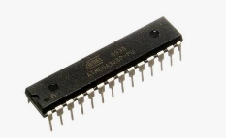

4.3 IV Fluid Monitoring Module
The IV fluid monitoring module is designed to monitor the remaining fluid in an intravenous container and detect possible interruptions in fluid flow. It combines weight measurement with infrared-based flow detection to provide complementary information about IV status.

4.3.1 Load Cell
A load cell is used to measure the weight of the IV fluid container. As the amount of fluid decreases, the measured weight also decreases. By calibrating the load cell and establishing an appropriate reference, the system can estimate changes in the remaining fluid quantity.
The load cell produces a small electrical signal proportional to the applied load. Because this signal is too small for direct measurement by many microcontrollers, a dedicated amplifier and converter are used.
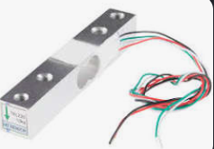

4.3.2 HX711 Load-Cell Amplifier
The HX711 is a precision amplifier and analog-to-digital converter designed for load-cell applications. It amplifies the load cell's differential output and converts it into digital data that can be processed by the ATmega328P.
The microcontroller communicates with the HX711 through its data output (DOUT) and serial clock (SCK) connections. The acquired measurements are processed using calibration values to estimate the load or fluid weight.
Calibration is important because raw sensor readings depend on the load cell, mechanical arrangement, electrical connections, and calibration parameters.
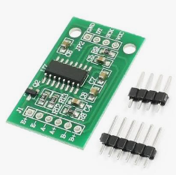

4.3.3 Infrared Flow-Detection Sensor
An infrared sensor is incorporated to detect fluid-flow activity through the IV drip mechanism. The sensor's digital output is read by the microcontroller, which evaluates the signal according to the sensor's operating characteristics.
The sensor output is used to identify flow-related conditions, such as detected activity or a possible interruption. The flow-detection result can be evaluated alongside the measured IV fluid weight to provide more useful status information.
The reliability of this method depends on sensor positioning, the physical drip arrangement, and appropriate testing. The infrared sensor should not be treated as a direct measurement of the infusion rate unless the system has been specifically calibrated and validated for that purpose.
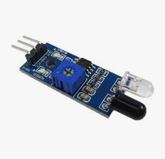

4.3.4 IV Status Indication
The microcontroller evaluates the weight measurement and flow-detection signal against predefined conditions. An indicator, such as an LED is activated when a configured threshold or abnormal condition is detected.
The relevant IV status is also intended to be made available to the centralized dashboard through the selected communication interface.
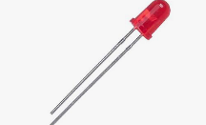

4.4 Room Temperature Regulation Module
The room temperature regulation module is designed to measure ambient temperature and control a suitable actuator according to predefined conditions.

4.4.1 Temperature Sensor
The temperature sensor measures the surrounding room temperature and provides readings to the control unit. the measurements are transferred through a digital communication interface or an analog signal.
The microcontroller processes the readings and compares them with the configured temperature limits. The accuracy of the resulting measurements depends on the sensor specifications, placement, environmental conditions, and calibration.
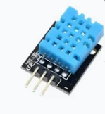

4.4.2 Actuator and Driver Circuit
The actuator provides the heating or cooling action required by the temperature regulation system. A driver circuit is used when the actuator requires more current or a different operating voltage than the microcontroller can provide directly.
The control circuit receives commands from the microcontroller and switches or regulates the actuator according to the selected control method. Suitable electrical protection and component ratings must be considered during implementation.
.

4.5 Medicine Reminder Module
The medicine reminder module generates notifications according to configured medication schedules. Its hardware design includes a timing component and suitable notification outputs.

4.5.1 Real-Time Clock Module
A Real-Time Clock (RTC) module maintains the current time and provides timing information to the controller. It allows scheduled reminders to be generated without relying solely on the microcontroller's internal timing functions.
The controller reads the time from the RTC and compares it with the configured reminder schedule. When a scheduled time is reached, the firmware generates the appropriate notification.
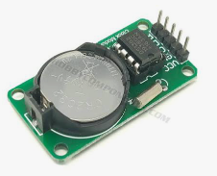

4.5.2 Notification Components
Notification components, such as an LED and LCD, is used to indicate that a medicine reminder is due.
The reminder system provides a scheduling function; it does not independently confirm that medication has been administered or taken.
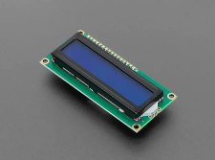

4.6 Dashboard and Communication Hardware
The centralized dashboard is the main interface for presenting information from MediGuard's modules. Its operation depends on a communication path between the embedded hardware and the dashboard software.
A suitable communication interface transfers module status, sensor measurements, and alert information to the dashboard. Depending on the implemented architecture, this may involve a wireless communication module, a serial connection, or another supported interface.
The communication hardware must be compatible with the selected controller and dashboard platform. Voltage compatibility, common ground requirements where applicable, data format, and communication reliability must be considered.
The dashboard hardware and communication arrangement should be documented using the actual components and connections implemented in the project.

4.7 Power Supply Design
The power supply provides the electrical energy required by the microcontroller, sensors, communication modules, and output devices. Each component must receive a supply voltage within its specified operating range.
Voltage regulation is required where components operate at different voltage levels. The power distribution design should also account for the current consumed by actuators and communication devices, as these may require more current than sensors or microcontrollers.
The design includes appropriate wiring, connectors, grounding, and protection against incorrect connections. If battery backup is included, its charging, protection, voltage regulation, and operating duration must be evaluated according to the selected battery and circuit design.

4.8 Hardware Integration
Hardware integration involves connecting the individual components so that they operate as parts of the MediGuard Smart Nurse Station. Each module must be checked independently before it is connected to the complete system.
The IV module requires proper connections between the load cell, HX711, infrared sensor, and controller. The temperature module requires connections between the temperature sensor, controller, and actuator driver. The medicine reminder module requires an RTC interface and notification outputs.
The dashboard communication interface is then connected according to the selected architecture. The integration process should verify power compatibility, signal connections, data exchange, and correct operation of the individual modules.
Testing each component separately before full integration helps identify wiring errors and simplifies troubleshooting.

CHAPTER FIVE: SOFTWARE DESIGN AND IMPLEMENTATION

5.1 Introduction
This chapter describes the software design and implementation of MediGuard, a Smart Nurse Station that integrates IV fluid monitoring, room temperature regulation, and medicine reminders with a centralized dashboard. The software is responsible for processing sensor data, executing control logic, generating notifications, and presenting system information.
The software is divided into embedded firmware for the hardware modules and dashboard software for centralized monitoring. This modular approach simplifies development, testing, maintenance, and future expansion.

5.2 Software Architecture
MediGuard follows a modular software architecture in which each module performs a specific function. The embedded firmware processes information from connected sensors and executes the required operations, while the dashboard presents the available information through a centralized interface.
The main software components are:
- IV monitoring software: Processes load-cell measurements and infrared sensor signals to determine IV status.
- Temperature regulation software: Reads temperature measurements and controls the selected actuator according to configured limits.
- Medicine reminder software: Compares the current time with configured schedules and generates reminders.
- Dashboard software: Displays module statuses, readings, and alerts.
- Communication software: Transfers information between the embedded modules and the dashboard.
The software components operate according to the selected hardware architecture and communication method.

5.3 Embedded Firmware Development
The embedded firmware is responsible for controlling the microcontroller and processing information from the connected hardware. The ATmega328P is used in the embedded-system development of MediGuard.
The firmware is developed in C, with separate functions or modules used to organize sensor interfacing, data processing, control operations, and notifications.
The main firmware tasks include:
- Initializing the microcontroller and peripherals.
- Reading sensor measurements and digital input signals.
- Processing sensor data and evaluating configured conditions.
- Executing temperature-control logic.
- Managing medicine reminder schedules.
- Generating status information and alerts.
- Transmitting relevant information to the dashboard, where communication is implemented.
Separating these tasks into modules makes the firmware easier to understand, debug, and extend.

5.4 IV Fluid Monitoring Software Flow 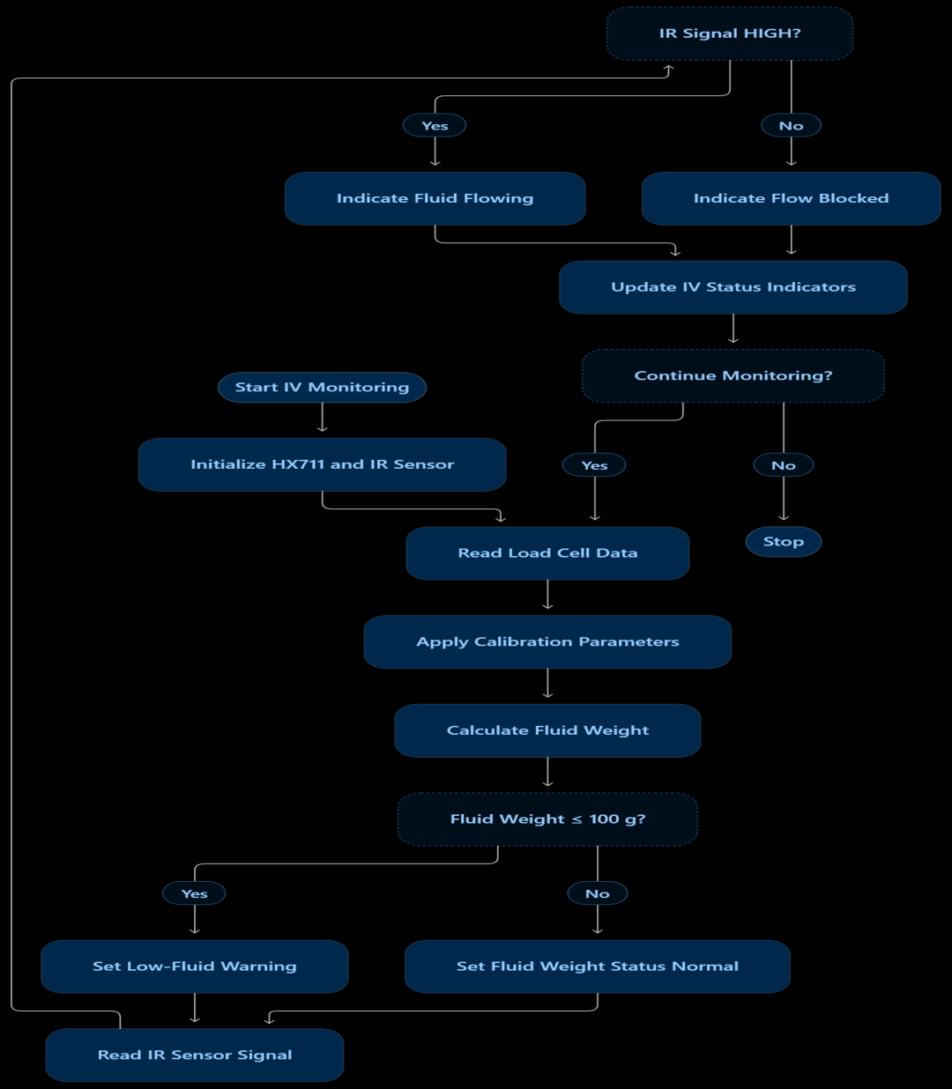

5.5 Temperature Regulation Software Flow

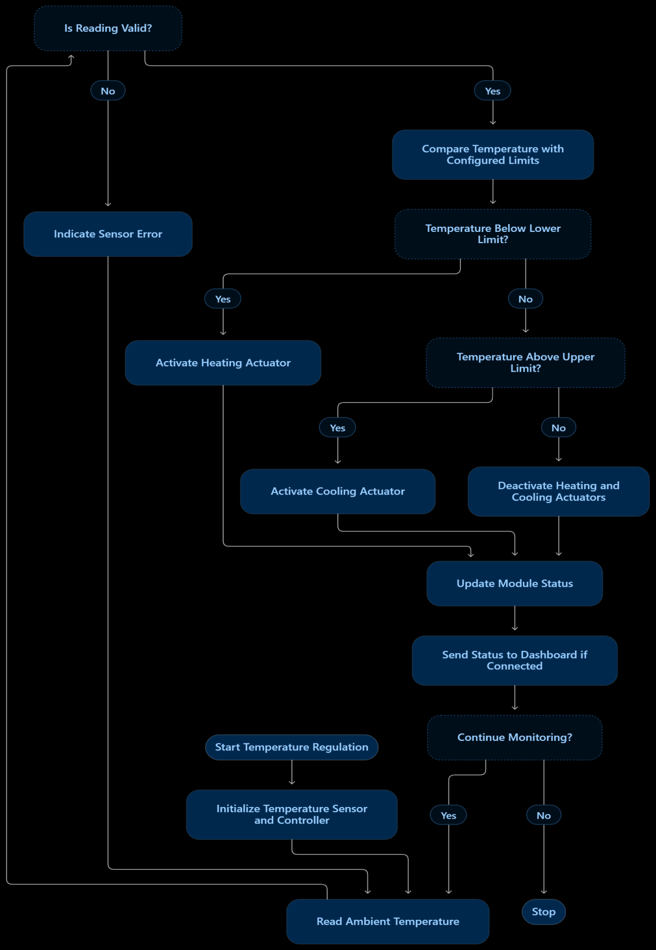

5.6 Medicine Reminder Software Flow

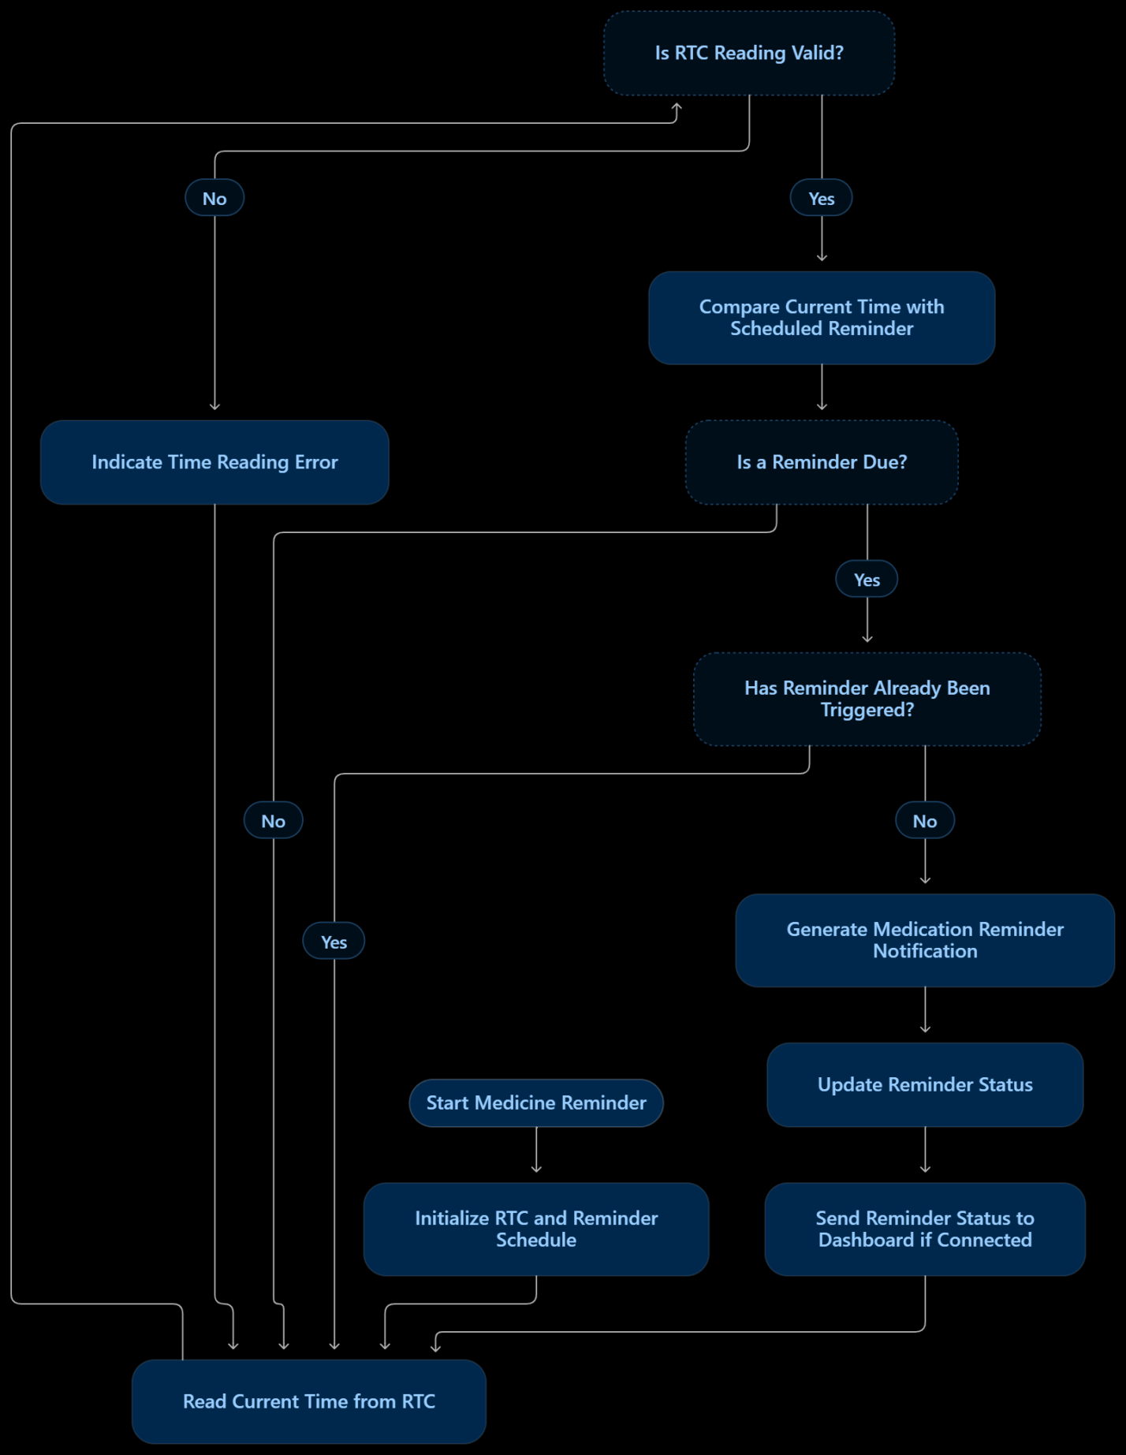

5.7 Dashboard Software Development
The MediGuard dashboard serves as the centralized interface for monitoring the system. It is designed to present relevant information from the IV monitoring, temperature regulation, and medicine reminder modules in an organized format.
The dashboard may include the following interface elements, depending on the implemented features:
- IV monitoring panel: Displays available fluid-weight measurements, flow status, and related alerts.
- Temperature panel: Displays the measured room temperature and actuator status.
- Medicine reminder panel: Displays configured schedules and reminder notifications.
- System status indicators: Show the operational status of available modules.
- Alert section: Presents conditions that require attention.
The dashboard uses clear labels and distinguish normal operation from warning conditions. It should also indicate communication failures or stale data when the required status information is no longer being received..

5.8 Software Testing and Debugging
Software testing is performed to verify that each function operates according to its requirements. Individual modules should be tested before complete system integration.
The IV monitoring software should be tested using known weights and controlled changes to the flow sensor input. The temperature-control software should be checked using different sensor readings and the expected actuator responses. The medicine reminder software should be tested with scheduled times to confirm that notifications are generated correctly.
Dashboard testing verify that available data is displayed accurately and that alerts and module statuses are presented as expected. Communication testing should check data transfer and identify how the system behaves when a connection is interrupted.
Any measured results, discovered errors, and corrective actions should be documented in Chapter Seven.

.

CHAPTER SIX: TESTING, RESULTS, AND DISCUSSION

6.1 Introduction
This chapter presents the testing, simulation results, PCB design, and evaluation of MediGuard, a Smart Nurse Station. The system is evaluated through its individual modules and their associated hardware and software designs. Proteus simulation screenshots are used to illustrate the circuit configurations and simulated operation, while PCB design screenshots present the physical circuit layout developed for implementation.
The chapter covers the IV fluid monitoring module, room temperature regulation module, medicine reminder module, and centralized dashboard. The results are discussed in relation to the project requirements, with distinctions made between simulated behavior, PCB design, and functions verified on physical hardware.

6.2 Testing and Evaluation Methodology
The evaluation of MediGuard involves examining the circuit designs, observing the behavior of the modules in Proteus, reviewing the PCB layouts, and checking the operation of the implemented software.
The evaluation is organized into the following stages:
- Circuit simulation: Examine the circuit connections and observe the behavior of the modules in Proteus.
- Module testing: Evaluate the individual functions of the IV monitoring, temperature regulation, and medicine reminder modules.
- PCB design verification: Inspect component placement, routing, and connections in the PCB layouts.
- Dashboard evaluation: Examine the presentation of module information and status indicators.
- System evaluation: Compare the observed results with the intended functional requirements.
Screenshots and observations are included as evidence of the design and testing process. Simulation results are distinguished from physical hardware test results, and only verified outcomes are reported as successful.

6.3 IV Fluid Monitoring Module Results
The IV fluid monitoring module uses a load cell with an HX711 amplifier to measure the weight of the IV fluid container and an infrared sensor to monitor the fluid-flow condition. The firmware evaluates the measurements using the configured low-fluid threshold and the infrared sensor signal.

6.3.1 Proteus Circuit Simulation
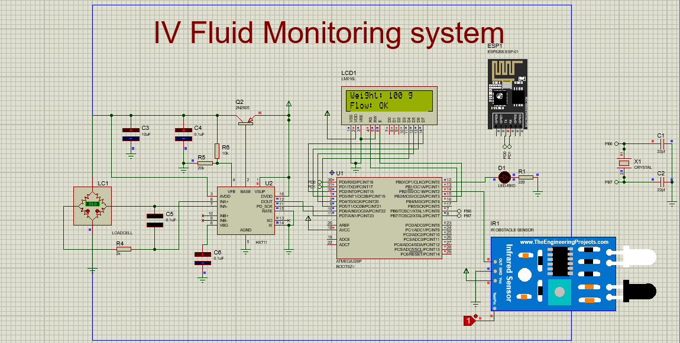Figure 6.1: Proteus simulation of the IV fluid monitoring module.
The simulation is examined to verify the circuit configuration and the response of the available inputs and outputs. Any observed behavior should be described according to the actual simulation results.

6.3.2 IV Monitoring PCB Design
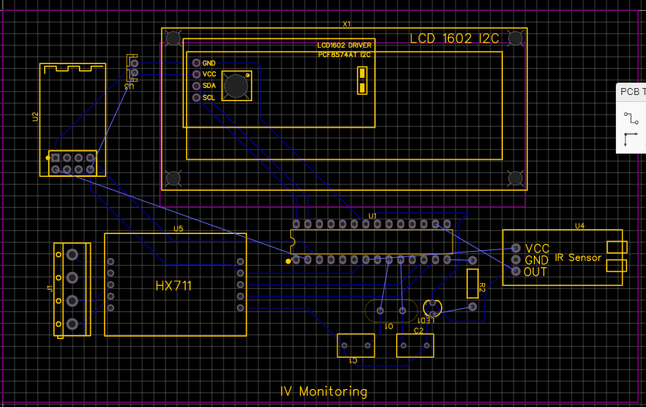Figure 6.2: PCB layout of the IV fluid monitoring module.

The PCB screenshot presents the component arrangement and routing of the circuit. The layout should be reviewed for component placement, track routing, connection continuity, and accessibility of external sensor and power connections.
The PCB layout demonstrates the hardware design prepared for implementation;

6.3.3 IV Monitoring Test Results
The principal IV monitoring tests are summarized in Table 7.1.
Test | Expected behavior | Observed result
Load-cell measurement | Weight reading corresponds to the applied reference load | Record measured value
Low-fluid threshold | Low-fluid condition is identified at the configured threshold | Record observed behavior
Flow detection | Sensor HIGH is interpreted as flow detected; LOW as flow blocked | Record observed behavior
Status indication | Available indicators reflect the detected condition | Record observed behavior

6.4 Room Temperature Regulation Module Results
The temperature regulation module measures ambient temperature and uses the controller's programmed logic to determine the appropriate actuator response.

6.4.1 Proteus Circuit Simulation
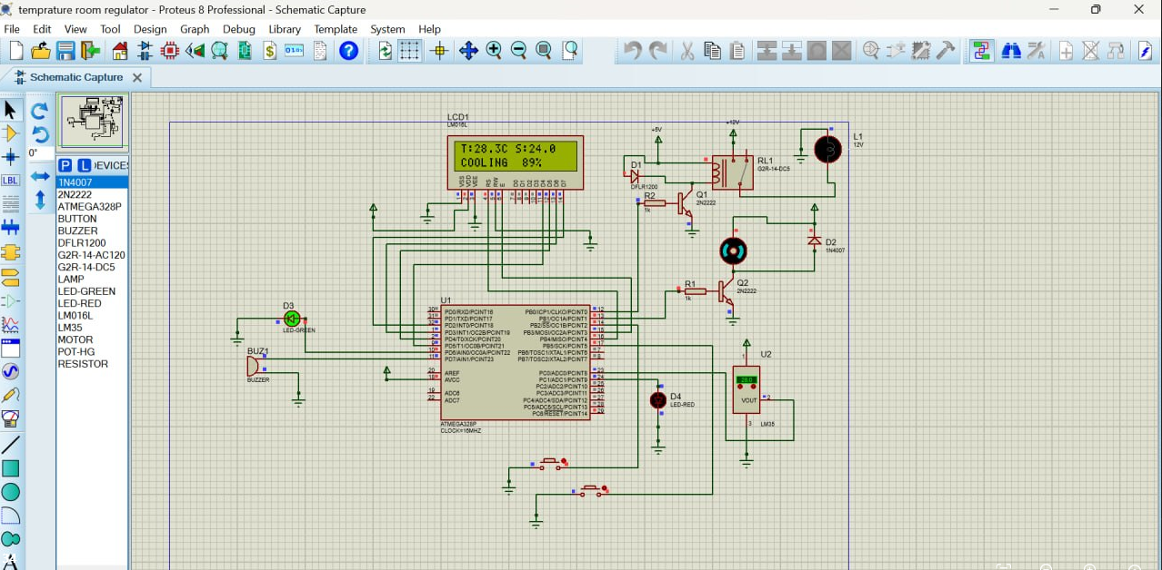Figure 6.3: Proteus simulation of the room temperature regulation module.

6.4.2 Temperature Regulation PCB Design
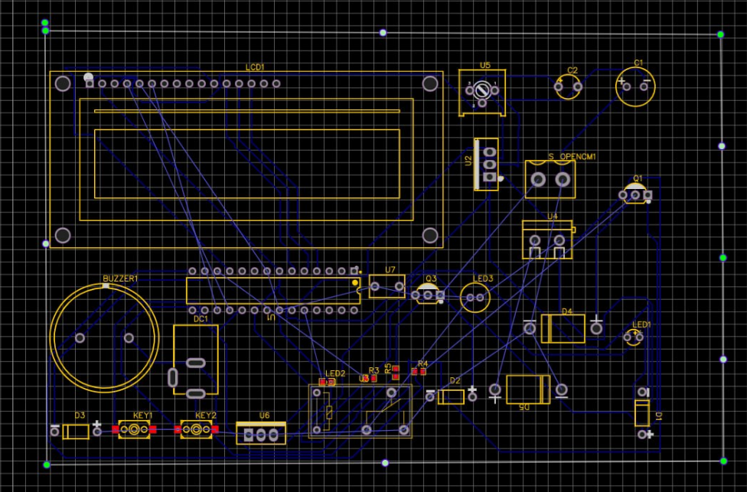Figure 6.4: PCB layout of the room temperature regulation module.
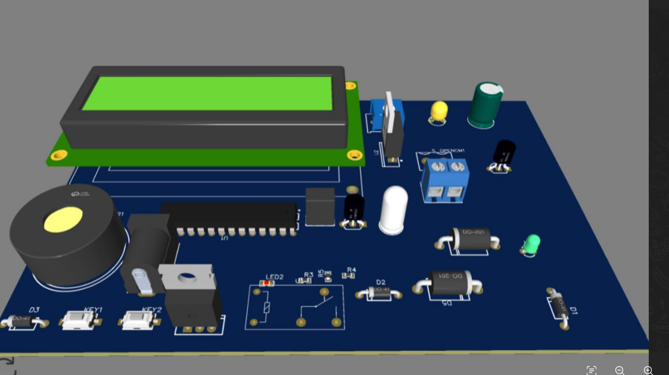
The PCB layout is reviewed to examine component placement, routing, power connections, and the interfaces between the controller, sensor, and actuator driver

6.4.3 Temperature Regulation Test Results
Test | Expected behavior | Observed result
Temperature measurement | Sensor provides a usable reading | Record measured reading
Temperature comparison | Controller evaluates the reading against configured limits | Record observed behavior
Actuator response | Actuator responds according to the implemented control logic | Record observed behavior
Sensor fault handling | Invalid readings are handled as implemented | Record observed behavior

6.5 Medicine Reminder Module Results
The medicine reminder module uses a real-time clock (RTC) to obtain time information and compares the current time with the configured reminder schedule.

6.5.1 Proteus Circuit Simulation
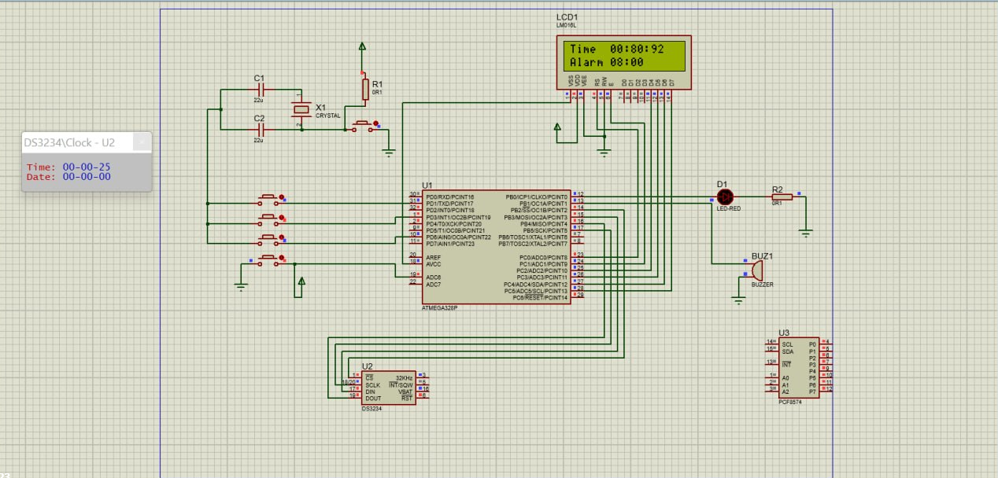Figure 6.5: Proteus simulation of the medicine reminder module.
The screenshot should show the RTC interface, microcontroller, and notification output used in the implemented design. Where the simulation supports it, include evidence of the time reading and reminder output.
The observed results should indicate whether the controller recognizes the configured reminder time and generates the intended notification.

6.5.2 Medicine Reminder PCB Design
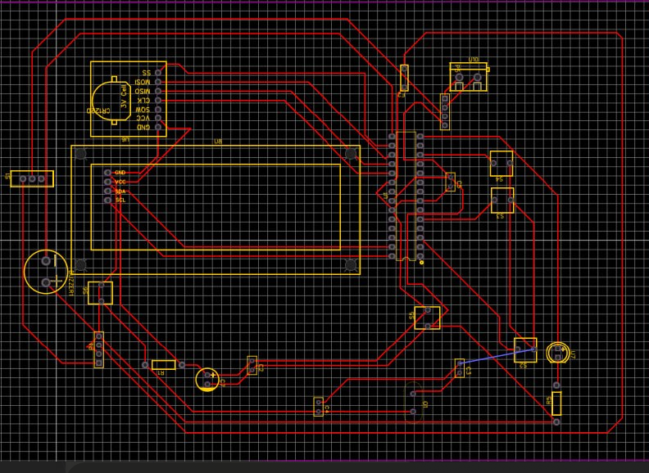Figure 6.6: PCB layout of the medicine reminder module.
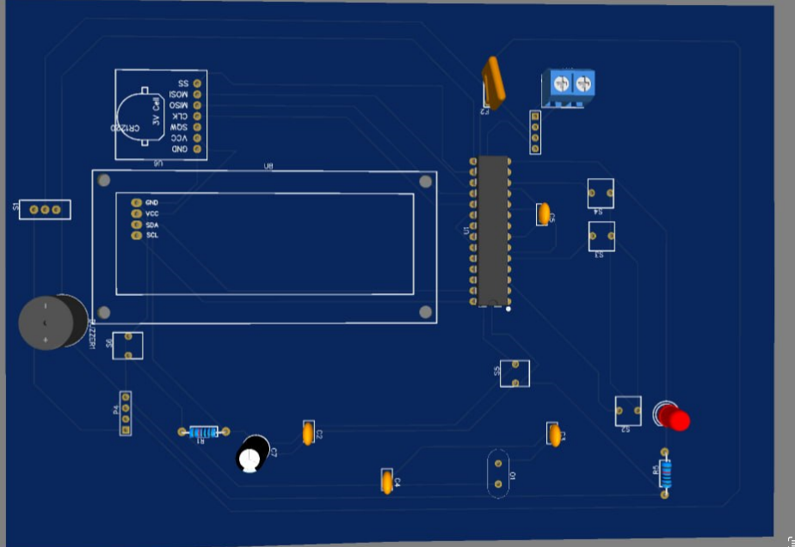
The PCB screenshot presents the physical circuit layout prepared for the medicine reminder module. The layout is inspected for component placement, routing, power connections, and the RTC and notification interfaces.

6.5.3 Medicine Reminder Test Results
Test | Expected behavior | Observed result
RTC operation | Correct time information is available | Record observed time
Schedule comparison | The configured reminder time is recognized | Record observed behavior
Notification generation | Notification is generated when due | Record notification behavior
Repeated notification handling | The same event is not repeatedly triggered unintentionally | Record observed behavior
The observed notification time should be compared with the configured schedule where timing measurements are available.

6.6 PCB Design Overview
This section presents the PCB designs developed for the MediGuard modules. The layouts provide a visual representation of the component placement, electrical routing, and interfaces required for the circuit implementation.
If the design was completed in a PCB design tool such as EasyEDA, include screenshots that clearly show the component side and routed tracks. A three-dimensional PCB view may also be included if available.
Each PCB figure should identify the relevant module and should be accompanied by a brief explanation of the layout. If the boards have been fabricated, photographs of the physical boards may be included separately from the software-generated PCB views..

6.7 System Integration and Overall Results
System integration evaluation examines the relationship between the individual modules and the centralized dashboard. The objective is to determine whether the available module information is processed and presented consistently.
The evaluation covers IV fluid status, temperature measurements and control status, scheduled medicine reminders, and the presentation of module information on the dashboard.
The results should distinguish among the following:
- Functions demonstrated in Proteus simulation.
- PCB layouts completed in the design software.
- Functions verified on fabricated hardware.
- Dashboard functions verified using live module data.
- Functions that remain untested or incomplete.
Table 6.5 provides a summary structure for reporting the overall results.
System component | Evidence | Result
IV fluid monitoring | Proteus screenshot and test observations | Record verified result
Temperature regulation | Proteus screenshot and test observations | Record verified result
Medicine reminder | Proteus screenshot and test observations | Record verified result
PCB design | PCB layout screenshots | Record design review result
Centralized dashboard | Dashboard screenshot and communication tests | Record verified result

6.9 Discussion
The simulation screenshots demonstrate the circuit configurations and the behaviors observed during testing. The PCB screenshots document the corresponding circuit layouts and provide evidence of the hardware design process. Together, these materials help explain how the individual modules were designed and how their implementations relate to the overall MediGuard architecture.
The effectiveness of the IV monitoring module depends on the accuracy of the load-cell measurements and the correct interpretation of the infrared sensor signal. The temperature regulation module depends on reliable temperature readings and correct actuator control. The medicine reminder module depends on accurate RTC information and correct schedule comparison.
The PCB layouts should be evaluated separately from the functional test results. Similarly, a dashboard screenshot demonstrates the user interface but does not establish that live data communication is operational. These distinctions are important when interpreting the project's achievements and limitations.
Any observed errors, incomplete functions, or discrepancies should be described with their likely causes and proposed corrective actions. Quantitative claims should be supported by recorded measurements, while qualitative claims should be supported by clearly described observations.

CHAPTER SEVEN: FUTURE IMPROVEMENTS

7.2 Integration of Heart Rate and Blood Oxygen Monitoring
A future version of MediGuard can incorporate a pulse oximeter module, such as the MAX30102, to measure heart rate and estimate peripheral blood oxygen saturation (SpO₂). The sensor uses optical measurements to obtain signals associated with blood circulation.
The collected measurements could be processed by a microcontroller and transmitted to the centralized dashboard for display. Configurable warning thresholds could help identify readings that require attention. This addition would expand MediGuard beyond equipment monitoring to include basic patient vital-sign monitoring.

7.3 Integration of ECG Monitoring
An electrocardiogram (ECG) monitoring module could be added using an ECG analog front-end such as the AD8232. The module would acquire electrical signals associated with the heart's activity through suitable electrodes.
The acquired signal could be processed and displayed as an ECG waveform on the dashboard. Further development could include signal filtering, heart-rate estimation, and detection of selected waveform irregularities. Such features would require appropriate signal validation and should not be considered a replacement for clinically validated ECG equipment.

7.4 Integration of Blood Pressure Monitoring
MediGuard could be extended with a blood pressure monitoring module to measure systolic and diastolic blood pressure. This could be implemented using a compatible electronic blood pressure monitor or a properly designed pressure-sensing system.
The measured values could be transferred to the dashboard alongside heart rate, SpO₂, and the existing module information. This would provide a broader overview of selected patient vital signs. The module would require appropriate calibration and validation against a reliable reference device before its measurements could be used for clinical decisions.

7.5 Integration of Body Temperature Monitoring
In addition to room temperature regulation, a separate body-temperature monitoring module could be incorporated. A suitable contact temperature sensor or non-contact infrared temperature sensor could be used to obtain a patient's temperature.
The measured value could be displayed on the dashboard, allowing room temperature and patient body temperature to be monitored as separate parameters. Appropriate sensor selection, calibration, and measurement procedures would be necessary to obtain meaningful readings.

7.6 Integration of a Wireless Nurse-Call System
A wireless nurse-call device could be introduced to allow a patient to request assistance by pressing a button on a bedside unit, wristband, or wearable device.
When activated, the device could transmit a nurse-call notification to the centralized dashboard, identifying the requesting patient or room where the system supports that information. The design could include acknowledgment and notification-status indicators to help staff track requests.

7.7 Expansion of Wireless Communication and Dashboard
The dashboard could be expanded to receive and display information from the additional vital-sign sensors and nurse-call devices. The interface could include separate sections for IV fluid status, room temperature, medicine reminders, heart rate, SpO₂, ECG, blood pressure, and body temperature.
Wireless communication modules, such as the ESP8266 or a suitable alternative, could be used to connect supported embedded modules to the dashboard. Future improvements could include communication-status monitoring, automatic reconnection, timestamped readings, historical data storage, and secure access control.
The communication architecture should be designed to identify unavailable or outdated measurements so that disconnected sensors are not mistaken for actively monitored devices.

7.8 PCB, Power Management, and Hardware Expansion
The addition of new monitoring modules would require further PCB development to accommodate sensor interfaces, microcontrollers, communication circuits, and power-management components.
Future hardware improvements could include modular PCBs, more compact circuit layouts, improved electrical-noise isolation, and suitable enclosures for the electronic components. A rechargeable battery backup could also be developed to maintain selected monitoring functions during power interruptions.
The power supply would need to be designed according to the current requirements of the connected sensors, controllers, and communication modules. Testing should include power consumption, battery endurance, voltage stability, and recovery after power loss.

7.9 System Validation and Safety
As MediGuard expands to include patient vital-sign monitoring, each additional module would require independent testing and validation. Sensor readings should be compared with suitable reference equipment, and the system should be evaluated under different operating conditions.
Additional testing should examine communication failures, sensor disconnections, electrical interference, and power interruptions. Appropriate electrical safety, patient protection, data security, and applicable medical-device requirements would need to be addressed before deployment in a clinical environment.
MediGuard should remain classified as a prototype until the necessary verification and validation have been completed.

CHAPTER EIGHT: CONCLUSION
MediGuard, a Smart Nurse Station, was developed to bring together several monitoring and support functions within a single system. The project focuses on three main modules: IV fluid monitoring, room temperature regulation, and medicine reminders, supported by a centralized dashboard.
The IV fluid monitoring module uses a load cell and HX711 interface to measure the weight of the IV fluid container, while an infrared sensor provides information about the fluid-flow condition. The temperature regulation module is designed to monitor ambient temperature and control an actuator according to its programmed logic. The medicine reminder module uses a real-time clock to compare the current time with configured medication schedules and generate reminders.
The project also involves embedded firmware development, circuit simulation, PCB design, and dashboard development. These activities demonstrate the application of embedded systems concepts to a healthcare-support prototype and provide a foundation for integrating sensing, control, timing, and user-interface functions.
MediGuard illustrates how multiple monitoring functions can be organized within a common system architecture. However, the extent to which each objective has been achieved must be determined from the actual simulation observations, PCB verification, hardware tests, and dashboard communication results documented in this report. Circuit designs and PCB layouts provide evidence of the design process, but they do not independently establish that every function has been validated on physical hardware.
Further development should focus on improving measurement accuracy, strengthening communication reliability, refining the user interface, and conducting more extensive testing under realistic operating conditions. Appropriate safety and performance validation would also be necessary before considering deployment in a clinical environment.
In conclusion, MediGuard provides a foundation for an integrated smart nurse-station prototype that combines IV fluid monitoring, temperature regulation, and scheduled medicine reminders. The project applies embedded systems design principles to a practical healthcare-support problem and establishes opportunities for further development toward a more reliable, maintainable, and thoroughly validated system.

